 SUBMITTED BY: ZULQARNAIN HAIDER
REG #: SP24-BSE-179
SUBJECT: Data Structure Lab 3
SUBMITTED TO: Nauman khan
DATE: 17-09-2025
____________________________________________________________
Lab Task 03
Data structure concept (Array Implementation)
Q1: Array data structure:
Instruction
Write a Java program to implement a menu-driven system for the following operations on an integer array and also design algorithm:
1. Traversal: • Display all elements in the array taken from the user.
2. Insertion: Insert an element: • At Beginning • At Given Position (take position from user) • At End
3. Deletion: Delete an element: • From Beginning • From Given Position (take position from user) • From End
4. Searching: • Linear Search (take value of key from user)
5. Exit
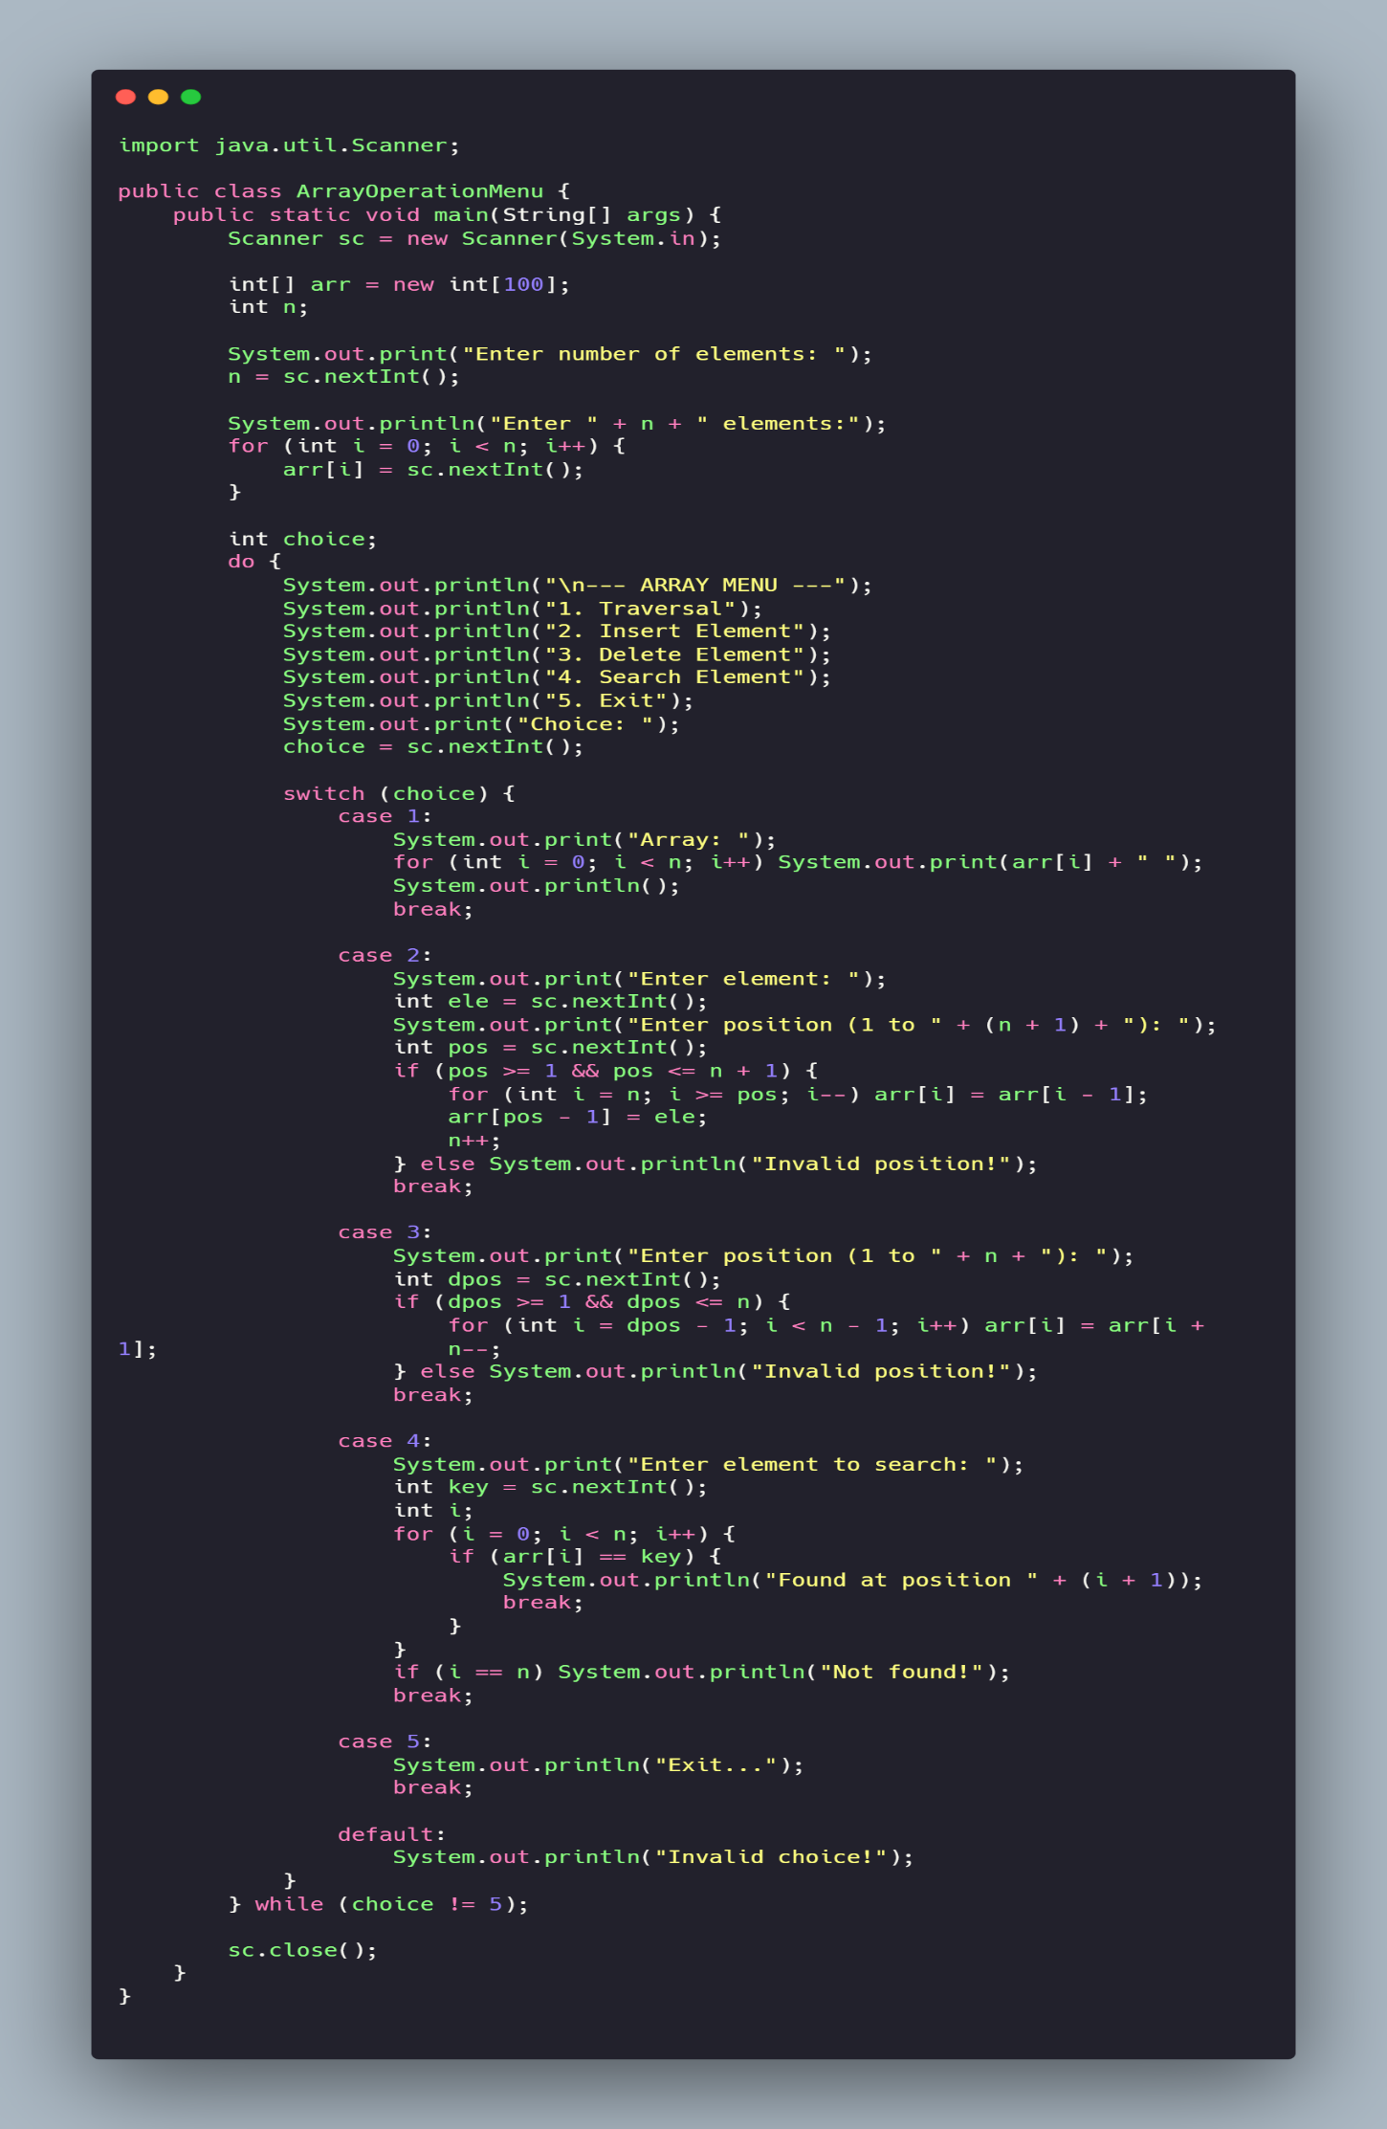
Output:
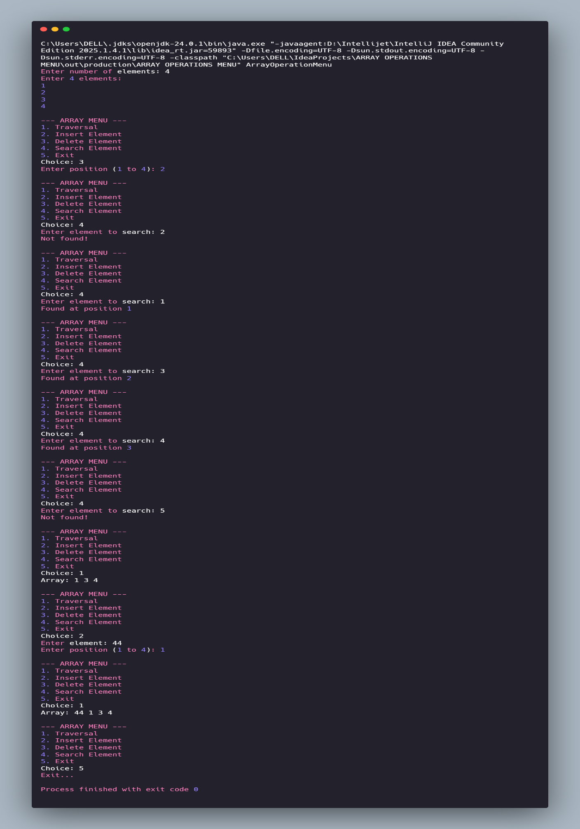

Algorithm: Array Operation Menu
- Step 1: Start
- Step 2: Create an array arr[100]
- Step 3: Input n (number of elements)
- Step 4: Enter n elements into the array
- Step 5: Repeat until the user chooses Exit:
  - Step 5.1: Display the menu
  - Step 5.2: Input user’s choice
  - Step 5.3: If choice = 1 → Display all elements (Traversal)
  - Step 5.4: If choice = 2 → Insert element at given position
    - Shift elements to the right
    - Place new element
    - Increase n by 1
  - Step 5.5: If choice = 3 → Delete element from given position
    - Shift elements to the left
    - Decrease n by 1
  - Step 5.6: If choice = 4 → Search element in the array (Linear Search)
    - If found → show position
    - Else → show "Not Found"
  - Step 5.7: If choice = 5 → Exit program
- Step 6: Stop

